

**ORDER FORM**

B. Factory Anodizing-outer rim with Black

Centers

***Wheel Finish Selections: Please refer to photo page on the fuchsrestoration.com website***

**Any Size Anodized, w/Exposed Paddles or Black Centers $295 RSR Finish Up to 8 inch $335**

**9 inch + $360**

***CIRCLE BELOW***

1. Factory Anodizing w/Exposed

Paddles and outer rim

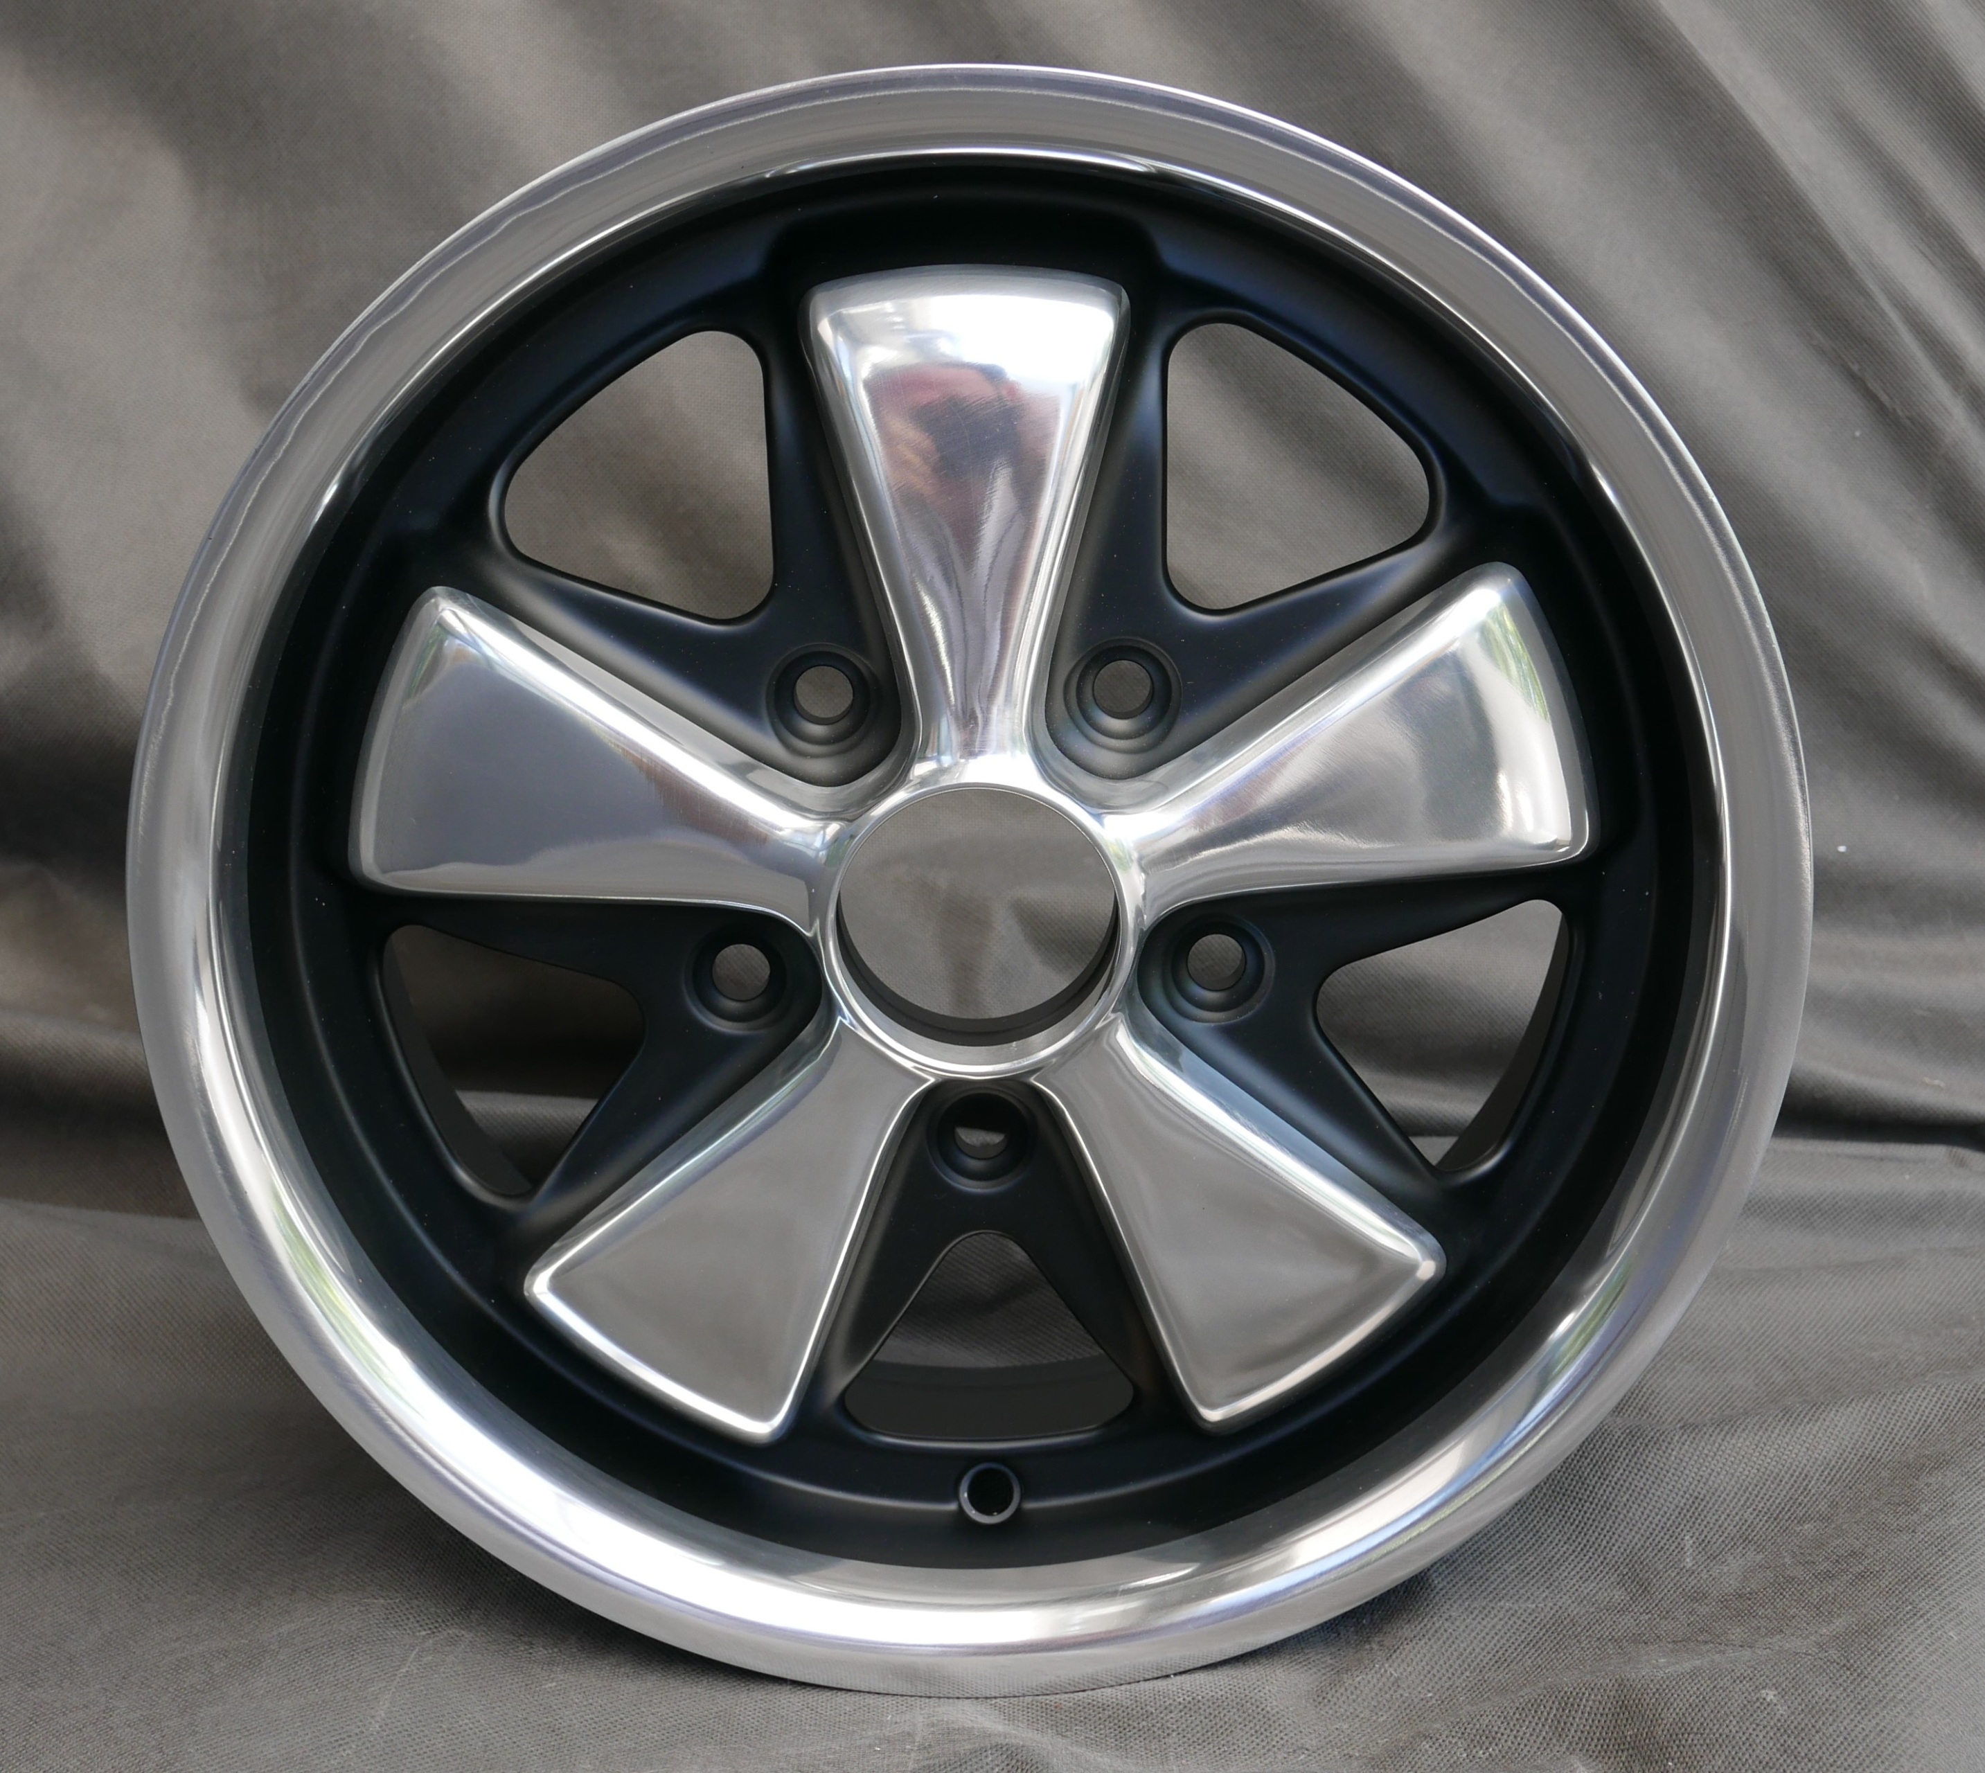 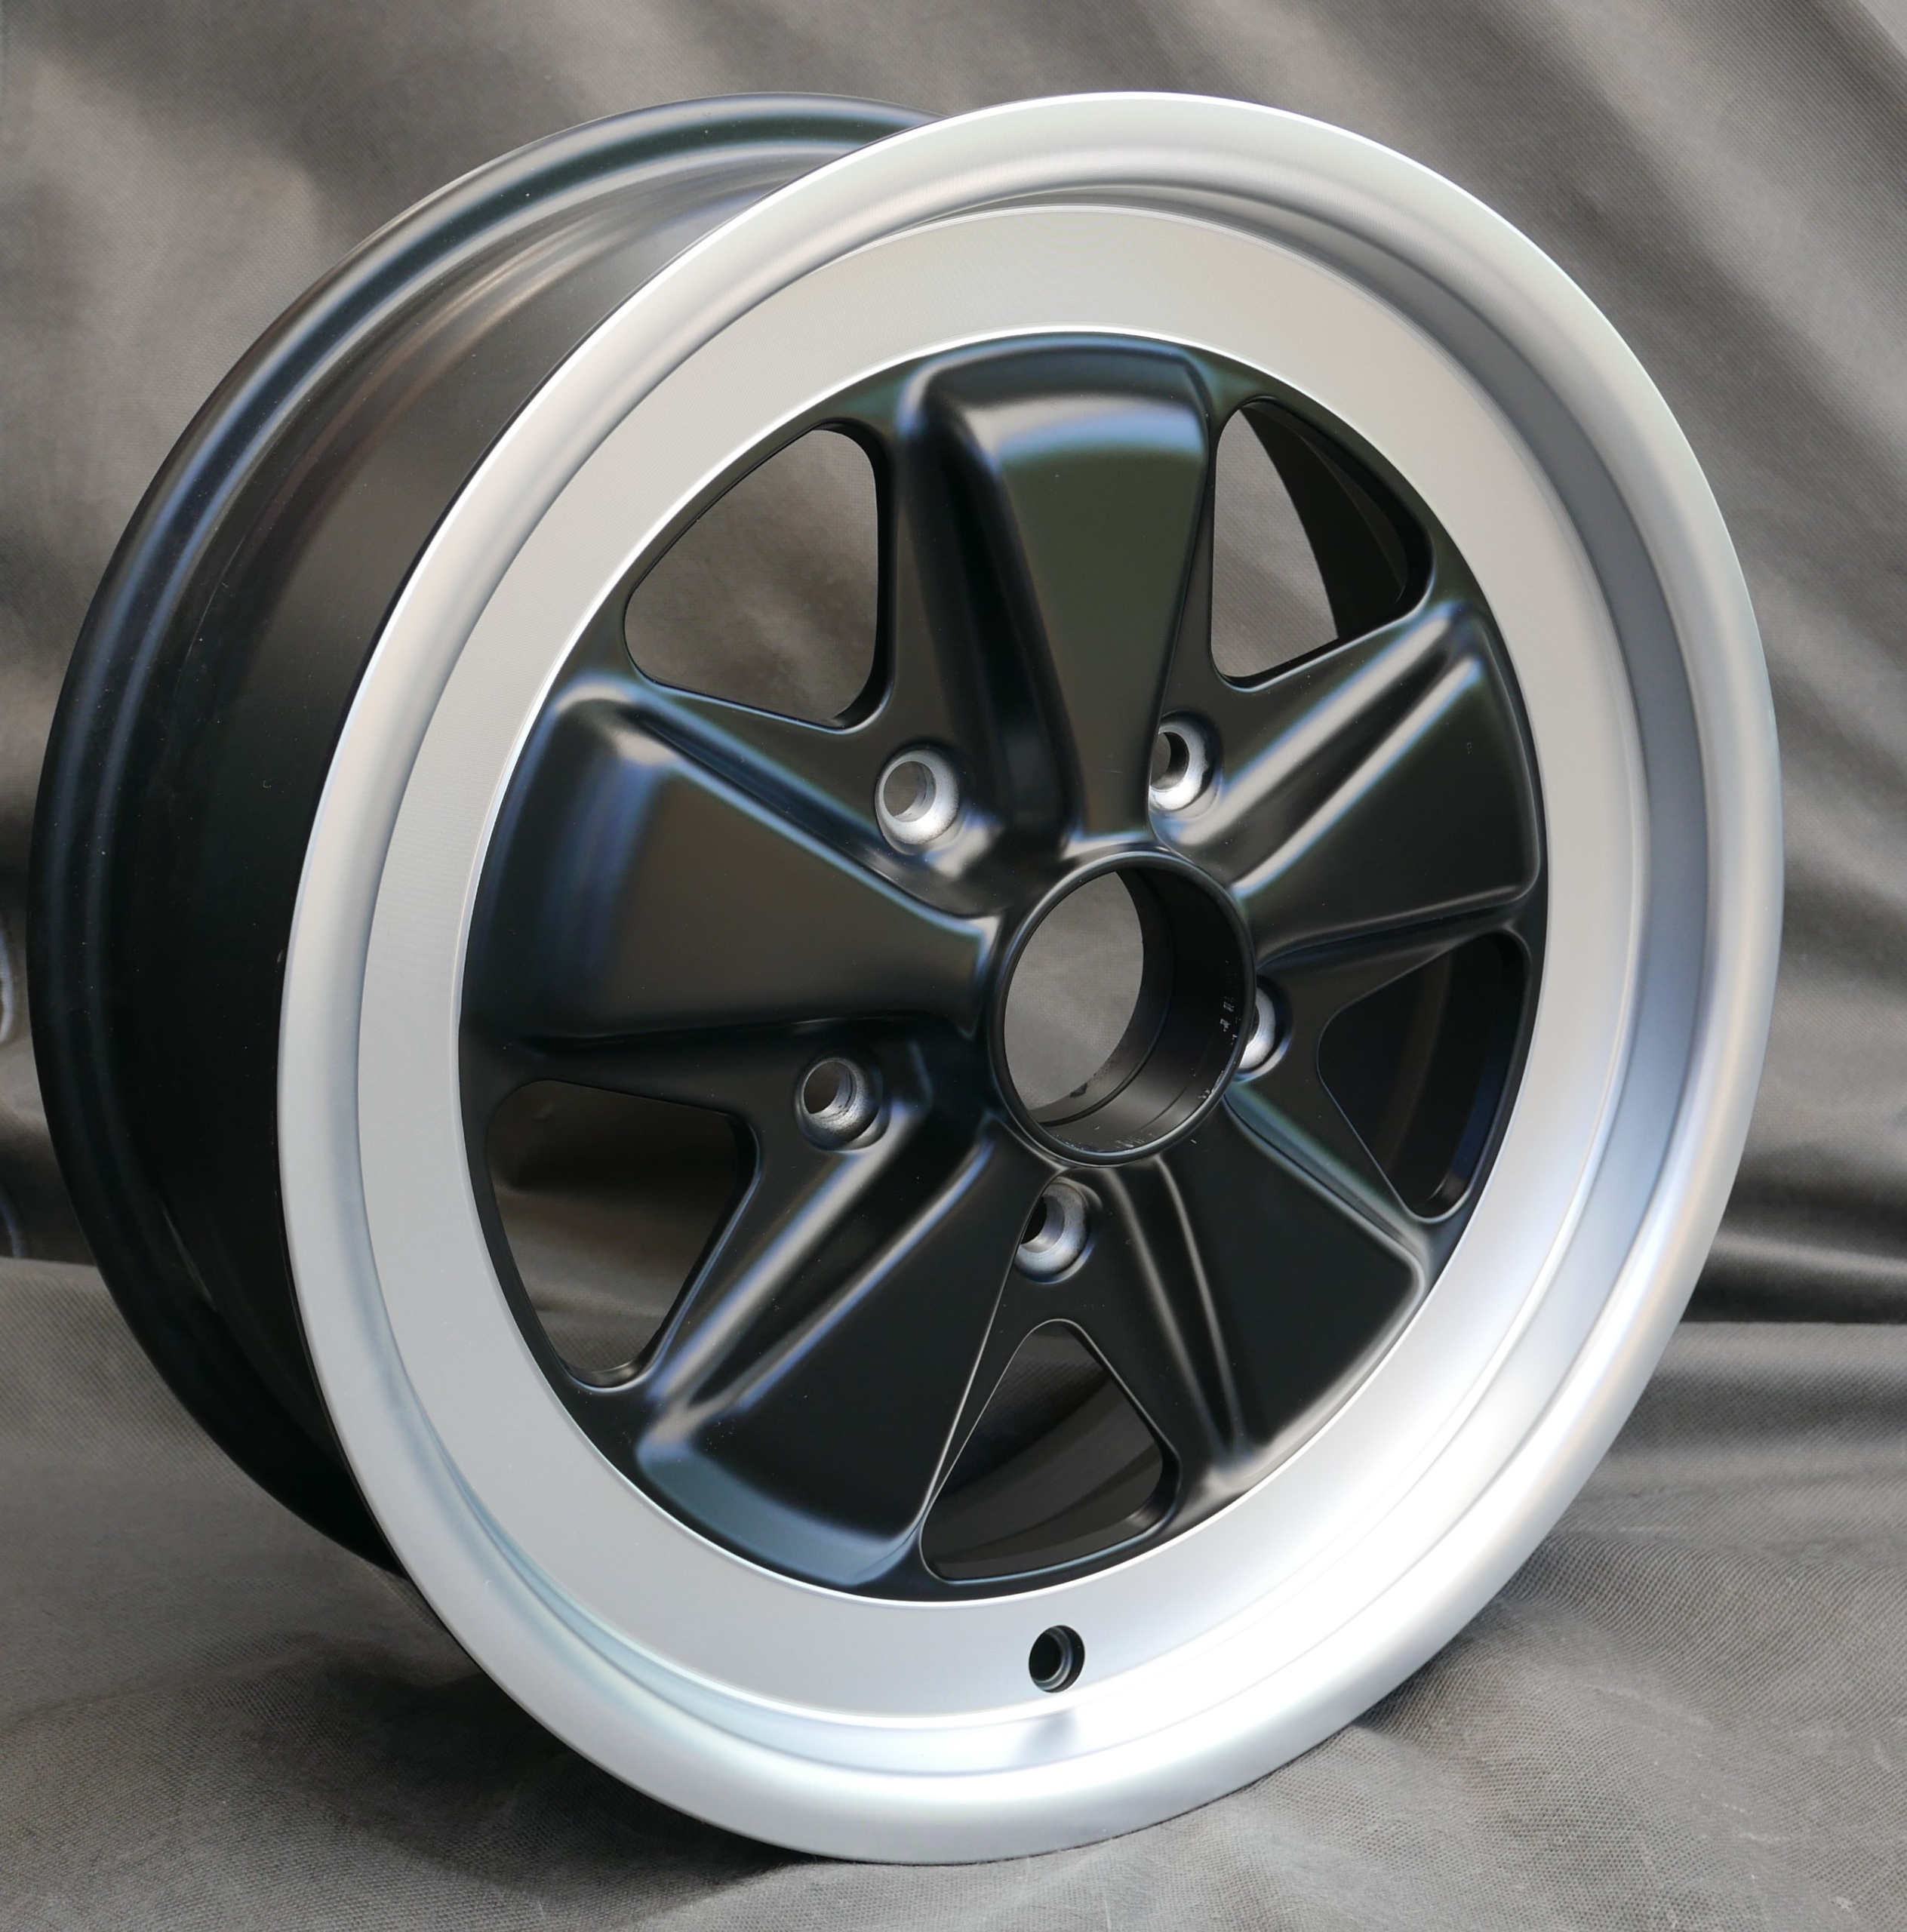

1. RSR Finish w/Exposed Paddles and outer rim
2. Fuchs style Keychain with rotating center $30

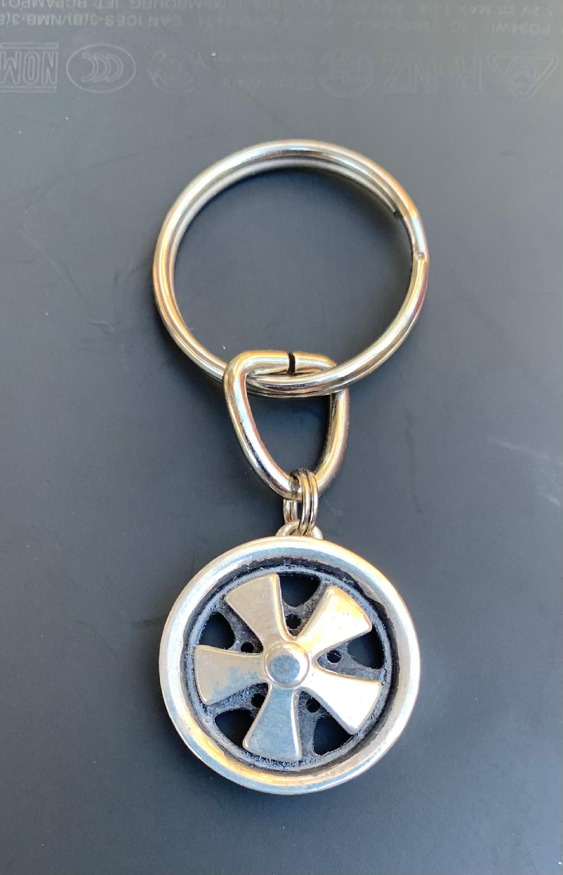

**Rubber Valve Stems Yes No $4 each**

**Yes No $6 for deep 6s and 7Rs**

**Metal Valve Stems Yes No $8 each (not appropriate for deep 6s or 7Rs)**

**Service backs/barrels of Wheels Yes No $75/Wheel**

This service includes bead blast of wheel, black paint of back barrel down to the part numbers. We

do not restore/repair the back as we do the face of the wheel. Part numbers will not be harmed.

**PLEASE WHEELS ONLY NO TIRES - *Please put a copy of this form in your shipped box(es) or email to*** [***ferraried@sbcglobal.net***](mailto:ferraried@sbcglobal.net)

**PLEASE ONLY SHIP FEDEX, UPS, OR DHL**

**SHIP TO: (local drop-off is ok, please call in advance)**

Fuchs Restoration

Air Cooled Garage

16011 Hope St.

Silverado, CA 92676

(949) 632-4559 - Cell/Text

**Date**

**Telephone #**

**Wheel Size**

**# of Caps**

**Name**

**Shipping Address**

**Email**